|  |
| --- |
| Boston University |
| ESME Workbench 2011 |
| User Guide |

|  |
| --- |
| Monday, 28 March 2011 |

Contents

Introduction 3

The One Navy Model 3

Transmission Loss Calculators 3

Marine Mammal Movement Models 3

The Team 3

The Purpose 3

The Purpose of This Document 3

ESME Workbench: User Interface Overview 4

The Ribbon Control 5

Configuration 5

Map Data 6

Overlays 6

Scenario 6

Environment 6

Sounds 6

Animals 7

Simulation 7

Reports 7

The Layer List 7

The Map 8

Workflow: Common Task Walkthroughs 9

Installation 9

Configuration 9

A Full Simulation: Flowchart 13

Building and Loading a Scenario 14

Extracting Environmental Data 14

Determining Environmental Boundaries: Quick Looks 14

Calculating Transmission Losses: Analysis Points 14

Defining Animal Model Populations 14

Modeling Sound Exposure of Animals 14

Post-Processing Simulation Data 14

API 15

# Introduction

This document describes the purpose, use, and appearance of ESME Workbench 2011. This software product integrates components of the Naval Underseas Warfare Center (NUWC), Biomimetica, and associated models into the One Navy Model (ONM) to model the Effects of Sound on the Marine Environment (ESME).

## The One Navy Model

The ONM is a collection of discrete software products written by Biomimetica, BU, NUWC, and others. It does stuff.

### Transmission Loss Calculators

**Bellhop**

**RAM**

**CASS**

**REFMS (?)**

### Marine Mammal Movement Models

**3MB**

## The Team

BU, NUWC, Biomimetica, … ?

## The Purpose

Let’s be nicer to whales. They never hurt nobody.

## The Purpose of This Document

Everyone should know how to run a full simulation at some level. Let’s instruct them.

# ESME Workbench: User Interface Overview

ESME Workbench is intended to be an intuitive primary user interface to the ONM. From its main screen, users can complete all the steps necessary to run a full simulation, stopping and restarting at any point to modify parameters, view environmental information, or do any other task required before a simulation is fully run.

The Workbench Main Screen is pictured below:

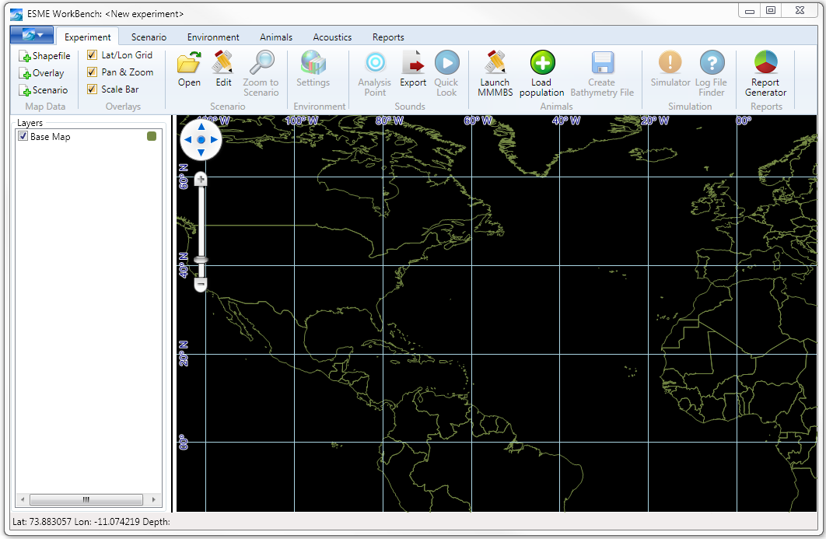

The Workbench has three main areas:

1. The **Ribbon Control**, highlighted in red, contains buttons and other tools to load, save, and configure experiment data. For example, Scenario Files can be loaded here.
2. The **Layer List**, highlighted in blue, contains a list of experiment data that is already loaded, and allows its manipulation. For example, Analysis Points, once created, can be manipulated here.
3. The **Map**, highlighted in green, contains a graphical display of data for users to make sense of their experiments.

Each area is described more fully in the following sections.

## The Ribbon Control

The ribbon control is the main way by which users add information to the experiment. There is a main application file menu, and several ribbon groups and tabs containing related buttons.

### Configuration

The large blue dropdown submenu is pictured below.

|  |  |
| --- | --- |
|  | |
| **Name** | **Function** |
| Recent Experiments | Lists recent experiments. Deleted or invalid experiments are not included. |
| Save Experiment | Opens a dialog box to save the experiment’s state to a .esme file. |
| Save Experiment As | Opens a dialog box to save a previously saved .esme file to a different name. |
| Open Experiment | Loads a previously saved .esme file and all associated metadata |
| Close Experiment | Unloads and removes all current experiment information. |
| New Experiment | Unloads and removes all current experiment information. |
| Info | Displays the build information about ESME Workbench and its libraries for bug-reporting purposes. |
| Options | Opens the global options dialog box, described later. |
| Help | Displays help information |
| Exit | Quits ESME Workbench |

### Map Data

The Map Data ribbon group contains three buttons.

|  |  |  |
| --- | --- | --- |
|  | **Name** | **Function** |
| Shapefile | Opens a dialog box for the user to select a shapefile(*.shp) to load to the map display. |
| Overlay | Opens a dialog box for the user to select an overlay file (*.ovr) to load to the map display. |
| Scenario | Opens a dialog box for the user to select a scenario file (*.nemo) to load to the map display. |

### Overlays

The Overlays ribbon group contains three check boxes.

|  |  |  |
| --- | --- | --- |
|  | **Name** | **Function** |
| Lat/Lon Grid | Toggles visibility of the grid display on the map. |
| Pan & Zoom | Toggles visibility of the on-map pan and zoom control widget. Mouse pan/zoom is not affected. |
| Scale Bar | Toggles visibility of the scale bar |

### Scenario

The Scenario ribbon group contains three buttons.

|  |  |  |
| --- | --- | --- |
|  | **Name** | **Function** |
| Open | Duplicates the functionality of the Map Data Scenario button. |
| Edit | Launches the NUWC Scenario Builder for users to create new *.nemo files. |
| Zoom to Scenario | This button is disabled until a valid Scenario File is loaded. When a valid scenario exists, clicking this button orients and zooms the map display to show the entire operational area. |

### Environment

The Environment ribbon group contains one button.

|  |  |  |
| --- | --- | --- |
|  | **Name** | **Function** |
| Settings | Launches the Environmental Data Extraction Dialog, where users can select which time periods and which resolution OAML environmental data they wish to use for the experiment. |

### Sounds

The Sounds ribbon group contains three buttons.

|  |  |  |
| --- | --- | --- |
|  | **Name** | **Function** |
| Analysis Point | Launches the Analysis Point dialog box, which begins the process of defining and placing an analysis point on the map. This button is disabled until a saved experiment exists that has valid environmental data extracted. |
| Export | Generates CASSOMatic batch files for all analysis points on the map. |
| Quick Look | Launches the Quick Look dialog box, which begins the process of running a quick look. |

### Animals

The Animals ribbon group contains three buttons.

|  |  |  |
| --- | --- | --- |
|  | **Name** | **Function** |
| Launch MMMBS | Launches MMMBS for users to interact directly with animat seeding operations. |
| Load Population | Loads a previously seeded population of animals (*.spe) and displays them on the map. |
| Create Bathymetry File | MMMBS requires direct access to bathymetric information about the operational area. Clicking this button extracts the current experiment bathymetry for use by MMMBS. |

### Simulation

The Simulation ribbon group contains two buttons.

|  |  |  |
| --- | --- | --- |
|  | **Name** | **Function** |
| Simulator | Launches the NUWC Scenario Simulator. This button is disabled until all required steps for a simulation have been taken and all CASS transmission loss calculations have finished. |
| Log File Finder | Launches an explorer window to display the Scenario Simulator log file directory, for troubleshooting. |

### Reports

The Reports ribbon group contains one button.

|  |  |  |
| --- | --- | --- |
|  | **Name** | **Function** |
| Report Generator | Launches the NUWC Report Generator once the Scenario Simulator has completed a scenario simulation. |

## The Layer List

The layer list allows the user to control the display of information on the map.

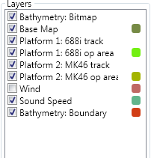The layer’s visibility, display order, and where appropriate, symbol, color, size, and line weight may all be adjusted.

**Visibility**

Each layer in the layer list has a **checkbox** next to its name. Toggling the checked status of the box correspondingly toggles the visibility of that layer on the map. Note: unchecking a layer does not delete its associated data.

**Display Order and Settings**

Right-clicking on the **layer name** displays a Layer Order context menu. This allows the user to move each layer up or down on the display. Layers “on top” of other layers obscure their predecessors. For some layers, such as Analysis Points, additional options to remove the layer or edit its settings are available.

**Symbols, Size, and Color**

Right-clicking on the **color box** associated with colorized layers allows the user to adjust:

* The displayed layer’s Color, via a standard Color Picker interface.
* The displayed layer’s Symbol, for those layers that have discrete data points.
* The displayed layer’s Line Width, for boundary layers.

## The Map

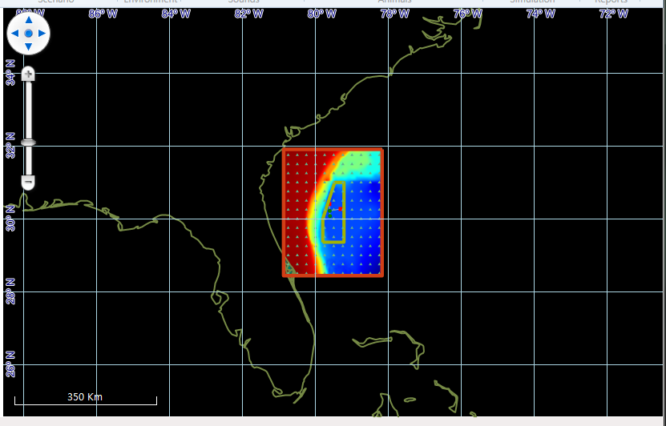

The Map is the primary interface by which data about the experiment is displayed to the user. Interactions with the map are primarily mouse-driven.

**Pan/Zoom**: The control highlighted in red, above, governs the zoom and position of the map data. Additionally, directly left-clicking and holding on the map with the mouse performs pan operations. For scroll wheel-equipped mice, the mouse wheel governs zoom level.

**Scale:**  The scale bar, highlighted in green, displays the current scale in kilometers.

**Cursor Location:** The coordinates of the cursor are displayed on the bottom taskbar of the Workbench, below the Layer List. For map areas with available bathymetric data, the depth is also displayed.

**Latitude/Longitude Grid**: The latitude and longitude grid is overlaid on the map, and dynamically adjusts its scale as needed.

# Workflow: Common Task Walkthroughs

Below are step by step walkthroughs for common tasks. Installation and configuration of ESME Workbench and the ONM are presented first. Then, a flowchart of one complete simulation is presented; in subsequent sections to it, each step is fully detailed.

## Installation

**System Requirements**

ESME Workbench requires a PC running Windows 7. A multi-core 64-bit CPU and 8GB of RAM is recommended.

An up-to-date release of Java is required to run any NUWC tools; ESME Workbench was tested against Java 6 SE, build 1.6.0_24-b07 .

**Environmental Databases and Extraction Tools**

The environmental data used by ESME Workbench to generate transmission losses is provided by four Oceanographic and Atmospheric Master Library (OAML) Databases:

1. The Re-Packed Bottom Sediment Type Database, Version 2.0 (BST)
2. The Digital Bathymetric Database – Variable Resolution, Version 4.5U (DBDB)
3. The Generalized Digital Environmental Model – Variable Resolution , Version 3.0.1 (GDEM-V)
4. The Surface Marine Gridded Climatology Database, Version 2.0 (SMGC)

These databases are available for download from the ESME project page located at <http://esme.bu.edu/> as four compressed files. The total space required for extracted databases is approximately 10GB.

**ESME Workbench 2011**

The latest build of ESME Workbench 2011 is provided as a MSI installer on http://esme.bu.edu/team/ in a folder corresponding to release date. Download the most recent version of the installer.

**Installation Procedure**

1. Ensure that all System Requirements are met.
2. Download and extract the OAML databases.
3. Run the ESME installer; a wizard will appear to guide you through the installation process.

## Configuration

Before simulations can be designed and run, some default configuration options must first be set. These are grouped into four tabs in the Options configuration window: **NAEMO**, **Environment**, **Acoustic** **Simulators**, and **Seasons**.

1. Launch ESME Workbench, and select the **Options** menu option from the main configuration dropdown menu.

|  |  |  |
| --- | --- | --- |
| **NAEMO Configuration Options** | | |
|  | Scenario Editor file | The location of the NUWC Scenario Builder ‘scenario-builder.jar’. This path is preconfigured, but if an updated version of the tool becomes available, the user may change it if needed. |
| Scenario Data Directory | The location of the Sim Areas folder for the given NUWC data directory from which PSM, Species information are derived and with which CASS interacts |
| Report Generator file | The location of the NUWC Report Generator, ‘post-processor.jar’. This path is preconfigured, but if an updated version of the tool becomes available, the user may change it if needed. |
| Scenario Simulator file | The location of the NUWC Scenario Simulator, ‘scene-sim.jar’. This path is preconfigured, but if an updated version of the tool becomes available, the user may change it if needed. |
| Number of Iterations | How many scenarios should be simulated when the Simulator button is pressed on the Ribbon Control. |
| Randomize Ship Tracks | If checked, the Scenario Simulator will randomize ship tracks. |

<COMMENTS ABOUT NAEMO STUFF HERE>

|  |  |  |
| --- | --- | --- |
| **OAML Environment Options** | | |
|  | GDEM-V | The path to the GDEM-V directory. The default name for this directory is ‘uncompressed’, and it contains 24 *.nc files. |
| SMGC | The path to the SMGC directory. The default name is ‘earth’, and it contains 64,800 *.stt files. |
| BST | The path to the BST database file. The default name is ‘hfevav2.h5’ |
| DBDB | The path to the DBDB database file. The default name is ‘dbdbv5_level0.h5’ |
| BST Extractor | The path to the BST extraction tool. This path is preconfigured, but if an updated version of the tool becomes available, the user may change it if needed. |
| DBDB Extractor | The path to the DBDB extraction tool. This path is preconfigured, but if an updated version of the tool becomes available, the user may change it if needed. |

|  |  |  |
| --- | --- | --- |
| **Acoustic Simulator / Transmission Loss Calculator Options: CASS** | | |
| C:\Projects\ESME Deliverables\Release Notes\screenshots\cass options.PNG | Generate Plot Files | These options collectively govern the format and content of generated CASS input and batch files. |
| Generate Binary Files |
| Generate Pressure Files |
| Generate Eigenray Files |
| Maximum Depth |
| Depth Step Size(m) |
| Range Step Size (m) |

|  |  |
| --- | --- |
| **Season Configuration Options** | |
| C:\Projects\ESME Deliverables\Release Notes\screenshots\season options.PNG | Each dropdown menu contains a list of calendar months.  Spring, Summer, Fall, and Winter are 3-month seasons that start at the first of the selected month.  Cold and Warm are 6-month seasons that start at the first of the selected month. |

## A Full Simulation: Flowchart



## Building and Loading a Scenario

PLACEHOLDER FOR NUWC DOCUMENTATION OR LINK TO IT.

## Extracting Environmental Data

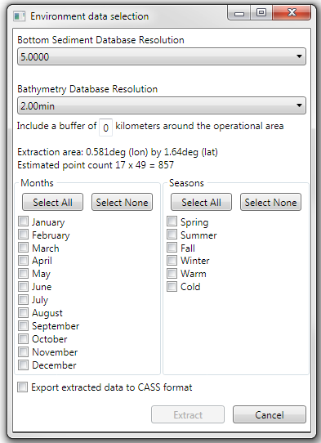

## Determining Environmental Boundaries: Quick Looks

TBD/NOT IMPLEMENTED.

## Calculating Transmission Losses: Analysis Points

## Defining Animal Model Populations

TBD/NOT IMPELENTED.

## Modeling Sound Exposure of Animals

PLACEHOLDER FOR NUWC DOCUMENTATION OR LINK TO IT.

## Post-Processing Simulation Data

PLACEHOLDER FOR NUWC DOCUMENTATION OR LINK TO IT.

# API

The ESME Workbench API is autogenerated for major releases using Doxygen